|  |  |  |  |  |
| --- | --- | --- | --- | --- |
| **R** | **C** | **V** | **T** | **Sign** |
|  |  |  |  |  |

7 **STQA Mini Project No. 2**

**7.1 Title**

Create a small web-based application by selecting relevant system environment/platform and programming languages. Narrate concise Test Plan consisting features to be tested and bug taxonomy. Narrate scripts in order to perform regression tests. Identify the bugs using Selenium WebDriver and IDEand generate test reports encompassing exploratory testing.

**7.2 Problem Definition:**

Perform Web testing and identify the bugs using Selenium WebDriver and IDEand generate test reports encompassing exploratory testing.

**7.3 Prerequisite:** Knowledge of Core Java .

**7.4 Software Requirements:**

Eclipse photon R latest Version, JAVA 1.8, selenium-server-standalone-3.13.0 Chromedriver.exe

**7.5 Hardware Requirement:**

PIV, 2GB RAM, 500 GB HDD, Lenovo A13-4089Model.

**7.6 Learning Objectives:**

We are going to learn how Identify the bugs using Selenium WebDriver and IDEand generate test reports encompassing exploratory testing.

**7.7 Outcomes:**

You are able to Web Testing using Automation Tool like Selenium Web driver and IDE .

**7.8 Theory Concepts:**

**7.8.1 What is Selenium?**

Selenium is a free (open source) automated testing suite for web applications across different browsers and platforms.

Selenium is a suite of software tools to automate Web Browsers.

• It is an Open source suite of tools mainly used for Functional and Regression Test Automation.

Selenium is a free (open source) automated testing suite for web applications across different browsers and platforms.

**7.8.2 Steps**

1. First of Download Latest Eclipse java photon-R version.

2. Download latest selenium-server-standalone-3.13.0 jar File.



3. Download and Extract Chromedriver.exefor windows on any drive of computer.

http://chromedriver.chromium.org/downloads**here 2.42 is latest version**



**4.** After Download Extract same on any Drive here I m extract on D Drive and my path of that exe file is H:\ec**\chromedriver_win32**

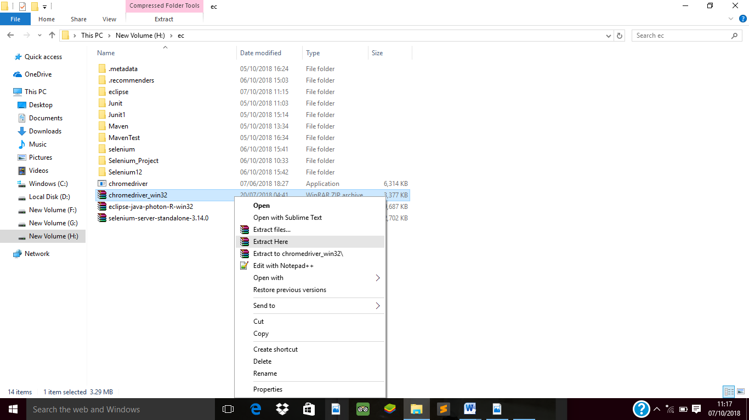

5. Now Open Eclipse IDE-----> Create Java Project=>Right Click Project Name=>Properties=>Java Build Path=>Libraries=>Add External JAR=>add selenium-server-standalone-3.13.0 jar =>Apply and Close.



6. Now Want **Open the chrome browser with Linkedin.com page via Selenium Web driver Java Coding** so here we need to write Java Code in Class file which we already created

7. Here in My Program I Create **Selenium_Project Java Project Folder name** and **Mac1.java is my class file** so write java code in this class file

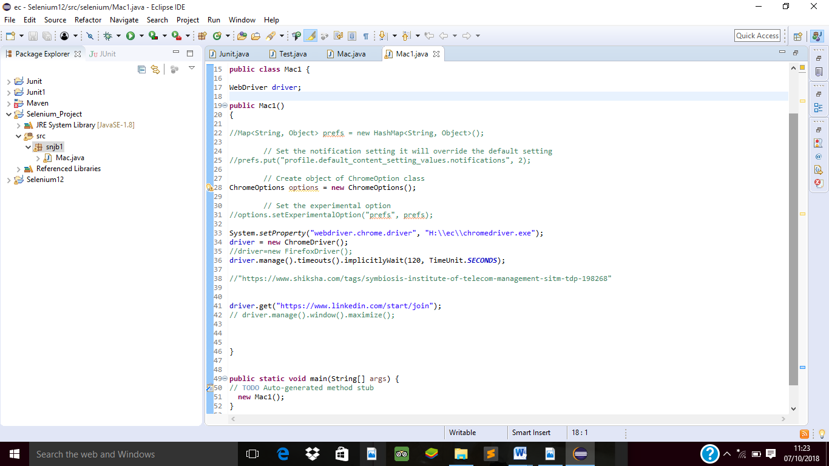

8. Right click on java program, select Run As and > "Java Application". After Code Successfully Run now see the output in Console Prompt .

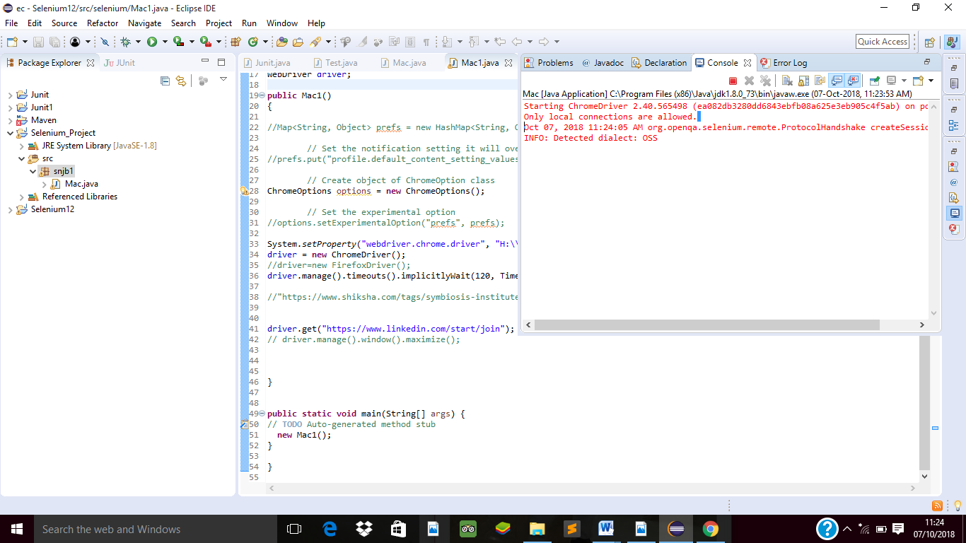

9. Now Your browser Open Automatically it shown data;

10. one more message display **chrome is being controlled by Automated Test Software**

**11.It mean we open chrome browser and linkedin.com page by selenium web driver java code Successfully.**

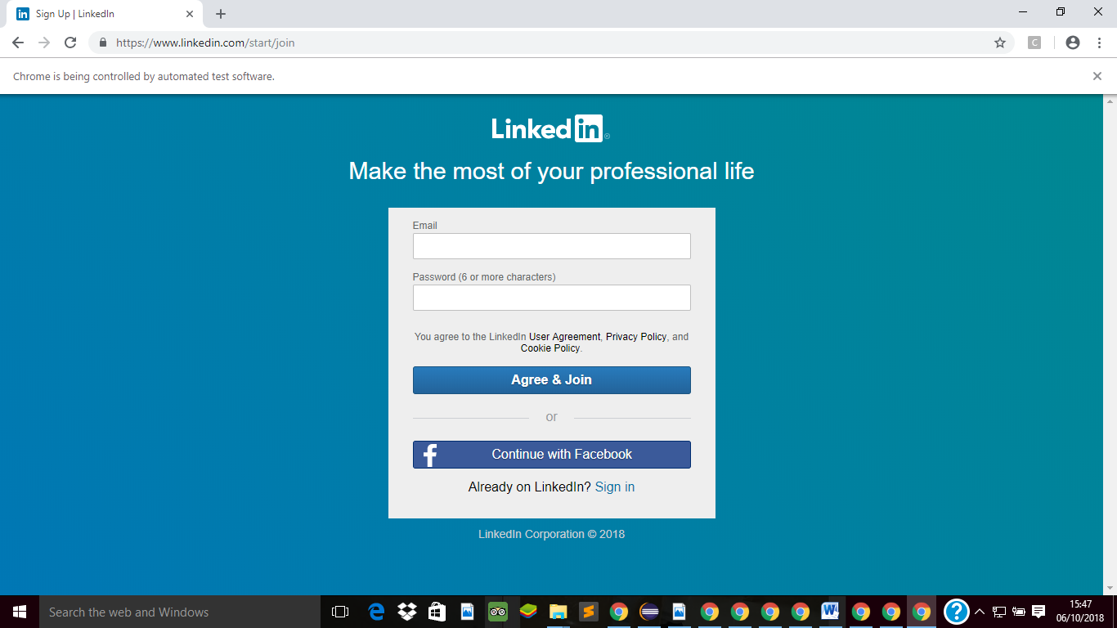

In this way Our First Module Run Successfully.

**Module-2 In This Project I want to fetch the user name and password on website Linkedin.com**

1. Create One Java Project Folder Give Name=>Selenium_Project=>Now Create One Class File give name Mac.java .
2. Right Click Project Name=>Properties=>Java Build Path=>Libraries=>Add External JAR=>add selenium-server-standalone-3.13.0 jar =>Apply and Close.

1. Similarly Copy the Chromedriver.exe file on my drive H:\ec**\chromedriver_win32** in this way.

4. Now Start right writing code for Mac.java to Collect review of social website.

Here I want to get user name and password and give login to Linkedin profile.

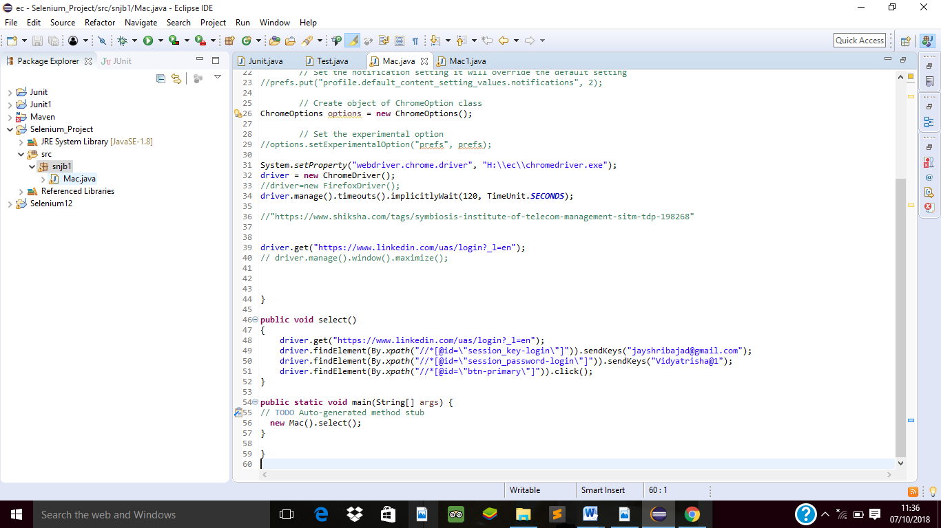

1. After Execution code Mac.java chrome browser opened automatically with specified website you can also see the output.

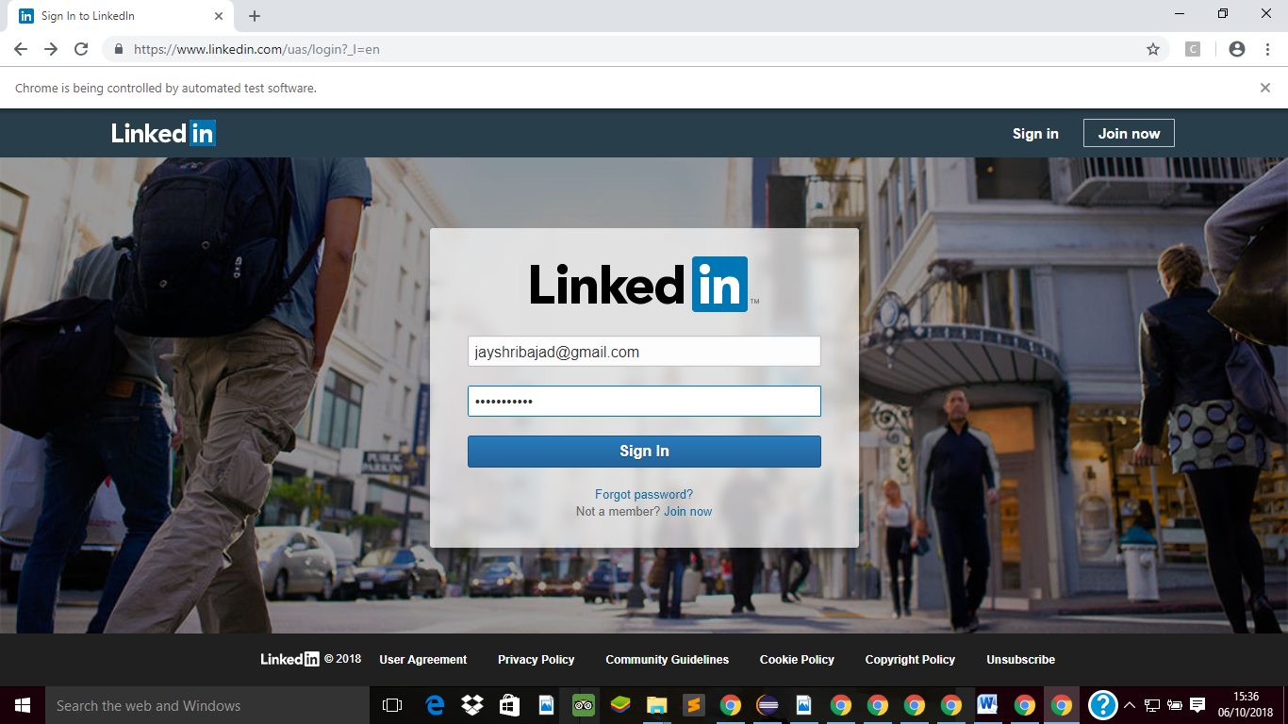

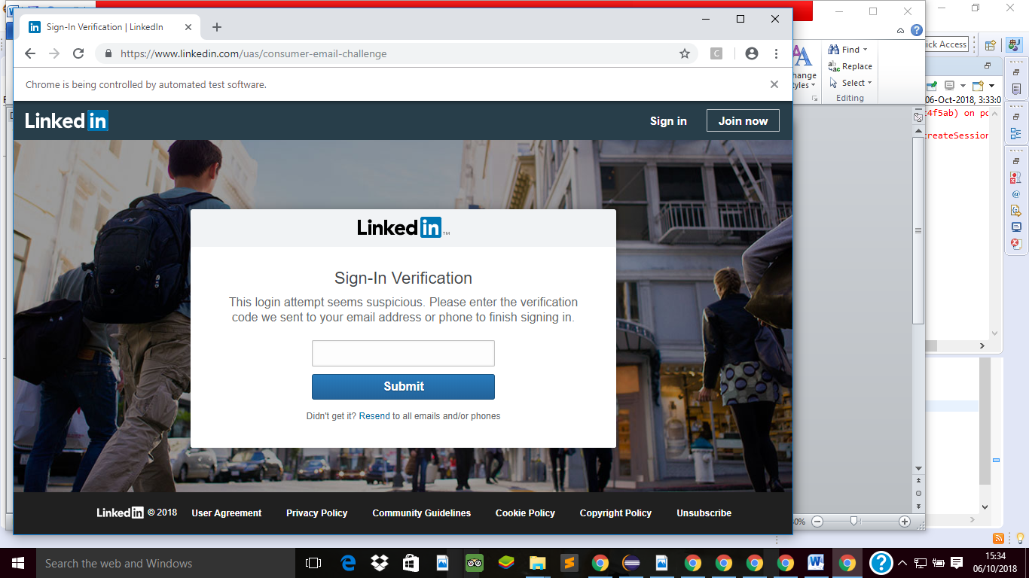

In this way you can fetch the data various website like Linkedin.com via Selenium Web driver Tool .

**Selenium IDE:**

1. Download Selenium IDE Chrome Extension from following Link

https://chrome.google.com/webstore/detail/selenium-ide/mooikfkahbdckldjjndioackbalphokd?hl=en

2. Click on Add to Chrome

3. Check the icon on of IDE Square in right side after browser after successfully installation to chrome

4. Now Click on record button do some operation on website…see the report in console of IDE command target and value….in this way you also find out xpath etc information.



